

Hi,

Thank You for showing interest to work with [www.hospet.online](http://www.hospet.online)

You have been shortlisted by our moderators.

You will receive Rs. 7000 /Month for 2 successive months if you are selected. We may consider hiring you if we like your work.

**PLEASE READ ALL INSTRUCTIONS CAREFULLY BEFORE REPLYING**

Before we begin your internship as a Web Developer, we would like to conduct a small test to get the idea of your skills.

You have to complete the assignment within 48 hours of receiving this email.

* You may not apply to this internship if you have previously applied for the same.

**Assignment** 1a

Do a google search for the keyword “Hospet online”, note down the position of hospet.online website on the search result page after you have clicked and verified the site URL exactly. (On desktop and mobile)

*In the below example the position of hospet.online website is 1st.*

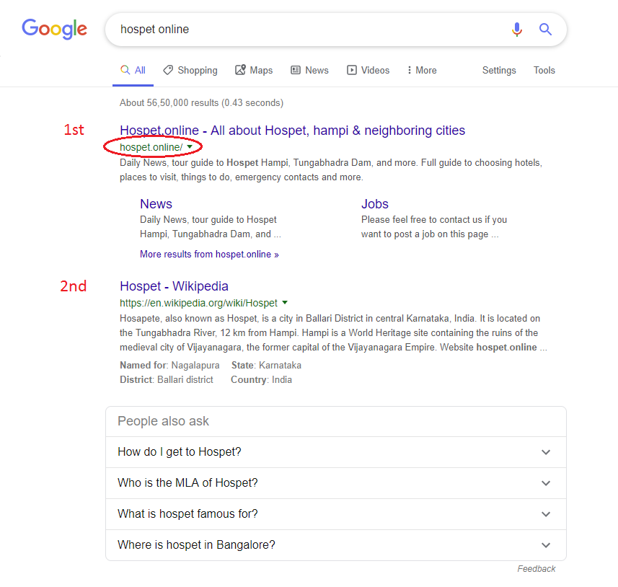

**Answer to assignment 1a**

**The position on hospet.online for the keyword “hospet online” on desktop version is**

Your answer

|  |
| --- |
|  |

**The position on hospet.online for the keyword “hospet online” on mobile version is**

Your answer

|  |
| --- |
|  |

**Assignment** 1b

Similar to assignment 1a, do a google search **(on a new tab)** for the keyword “Hospet”, note down the position of hospet.online website on the search result page after you have clicked and verified the site URL exactly. (Search up to 7 pages until you find the URL) (On desktop and mobile)

**Answer to assignment 1b**

**The position on hospet.online for the keyword “hospet” on desktop version is**

Your answer

|  |
| --- |
|  |

**The position on hospet.online for the keyword “hospet” on mobile version is**

Your answer

|  |
| --- |
|  |

2

Browse through all the pages of hospet.online and tell us what do you think. What did you like the most about the website? Is there something that you didn’t like? How can you help hospet.online?

Check all pages for any UI improvements and take notes along with the page URL.

Inspect for minor and major flaws and take notes along with the page URL.

Your answer

*600 words minimum*

|  |
| --- |
|  |
|  |
|  |
|  |
|  |
|  |
|  |
|  |
|  |
|  |
|  |
|  |
|  |
|  |
|  |
|  |
|  |
|  |
|  |
|  |
|  |
|  |
|  |
|  |
|  |
|  |
|  |
|  |
|  |
|  |
|  |
|  |
|  |
|  |
|  |
|  |
|  |
|  |
|  |
|  |
|  |
|  |
|  |
|  |
|  |
|  |
|  |
|  |
|  |
|  |
|  |
|  |
|  |
|  |
|  |
|  |
|  |
|  |
|  |
|  |
|  |

Any additional files like image or video can be attached along with the email.

You may reply to us directly or get in touch through the details below.

Email: [intern@hospet.online](mailto:intern@hospet.online)

We wish you all the best.